ACID Properties | ACID Properties in DBMS

Transaction in DBMS-

We have discussed-
- A transaction is a set of logically related operations.
- A transaction goes through different states throughout its life cycle.
- The life cycle of a transaction is-

ACID Properties-

- It is important to ensure that the database remains consistent before and after the transaction.
- To ensure the consistency of database, certain properties are followed by all the transactions occurring in the system.
- These properties are called as ACID Properties of a transaction.

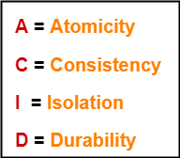

1. Atomicity-

- This property ensures that either the transaction occurs completely or it does not occur at all.
- In other words, it ensures that no transaction occurs partially.
- That is why, it is also referred to as “All or nothing rule“.
- It is the responsibility of Transaction Control Manager to ensure atomicity of the transactions.

2. Consistency-

- This property ensures that integrity constraints are maintained.
- In other words, it ensures that the database remains consistent before and after the transaction.
- It is the responsibility of DBMS and application programmer to ensure consistency of the database.

3. Isolation-

- This property ensures that multiple transactions can occur simultaneously without causing any inconsistency.
- During execution, each transaction feels as if it is getting executed alone in the system.
- A transaction does not realize that there are other transactions as well getting executed parallely.
- Changes made by a transaction becomes visible to other transactions only after they are written in the memory.
- The resultant state of the system after executing all the transactions is same as the state that would be achieved if the transactions were executed serially one after the other.
- It is the responsibility of concurrency control manager to ensure isolation for all the transactions.

4. Durability-

- This property ensures that all the changes made by a transaction after its successful execution are written successfully to the disk.
- It also ensures that these changes exist permanently and are never lost even if there occurs a failure of any kind.
- It is the responsibility of recovery manager to ensure durability in the database.

Transaction in DBMS-

“Transaction is a set of operations which are all logically related.”
OR
“Transaction is a single logical unit of work formed by a set of operations.”

Operations in Transaction-

The main operations in a transaction are-
- Read Operation
- Write Operation

1. Read Operation-

- Read operation reads the data from the database and then stores it in the buffer in main memory.
- For example- Read(A) instruction will read the value of A from the database and will store it in the buffer in main memory.

2. Write Operation-

- Write operation writes the updated data value back to the database from the buffer.
- For example- Write(A) will write the updated value of A from the buffer to the database.

Transaction States-

A transaction goes through many different states throughout its life cycle.
These states are called as transaction states.
Transaction states are as follows-
- Active state
- Partially committed state
- Committed state
- Failed state
- Aborted state
- Terminated state

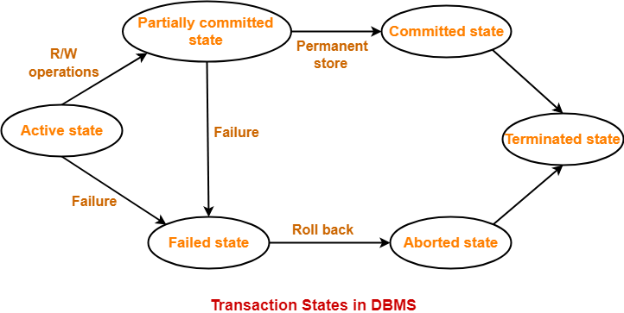

1. Active State-

- This is the first state in the life cycle of a transaction.
- A transaction is called in an active state as long as its instructions are getting executed.
- All the changes made by the transaction now are stored in the buffer in main memory.

2. Partially Committed State-

- After the last instruction of transaction has executed, it enters into a partially committed state.
- After entering this state, the transaction is considered to be partially committed.
- It is not considered fully committed because all the changes made by the transaction are still stored in the buffer in main memory.

3. Committed State-

- After all the changes made by the transaction have been successfully stored into the database, it enters into a committed state.
- Now, the transaction is considered to be fully committed.

NOTE-

- After a transaction has entered the committed state, it is not possible to roll back the transaction.
- In other words, it is not possible to undo the changes that has been made by the transaction.
- This is because the system is updated into a new consistent state.
- The only way to undo the changes is by carrying out another transaction called as compensating transaction that performs the reverse operations.

4. Failed State-

- When a transaction is getting executed in the active state or partially committed state and some failure occurs due to which it becomes impossible to continue the execution, it enters into a failed state.

5. Aborted State-

- After the transaction has failed and entered into a failed state, all the changes made by it have to be undone.
- To undo the changes made by the transaction, it becomes necessary to roll back the transaction.
- After the transaction has rolled back completely, it enters into an aborted state.

6. Terminated State-

- This is the last state in the life cycle of a transaction.
- After entering the committed state or aborted state, the transaction finally enters into a terminated state where its life cycle finally comes to an end.

Schedules in DBMS-

The order in which the operations of multiple transactions appear for execution is called as a schedule.

Types of Schedules-

In DBMS, schedules may be classified as-

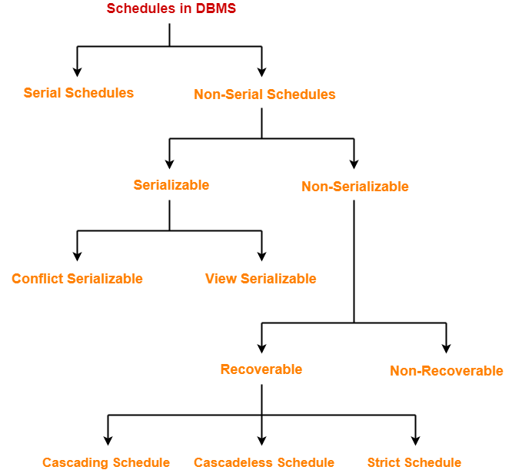

Serial Schedules-

In serial schedules,
- All the transactions execute serially one after the other.
- When one transaction executes, no other transaction is allowed to execute.

Characteristics-

Serial schedules are always-
- Consistent
- Recoverable
- Cascadeless
- Strict

Example-01:

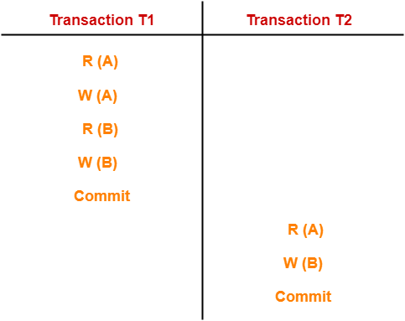

In this schedule,
- There are two transactions T1 and T2 executing serially one after the other.
- Transaction T1 executes first.
- After T1 completes its execution, transaction T2 executes.
- So, this schedule is an example of a Serial Schedule.

Example-02:

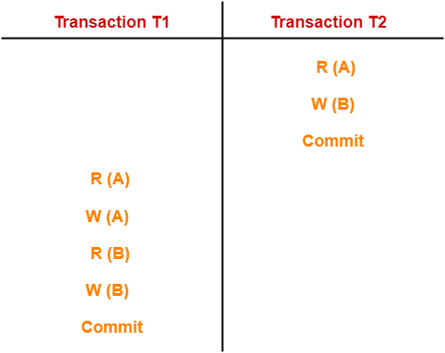

In this schedule,
- There are two transactions T1 and T2 executing serially one after the other.
- Transaction T2 executes first.
- After T2 completes its execution, transaction T1 executes.
- So, this schedule is an example of a Serial Schedule.

Non-Serial Schedules-

In non-serial schedules,
- Multiple transactions execute concurrently.
- Operations of all the transactions are inter leaved or mixed with each other.

Characteristics-

Non-serial schedules are NOT always-
- Consistent
- Recoverable
- Cascadeless
- Strict

Example-01:

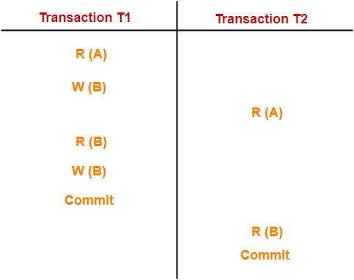

In this schedule,
- There are two transactions T1 and T2 executing concurrently.
- The operations of T1 and T2 are interleaved.
- So, this schedule is an example of a Non-Serial Schedule.

Example-02:

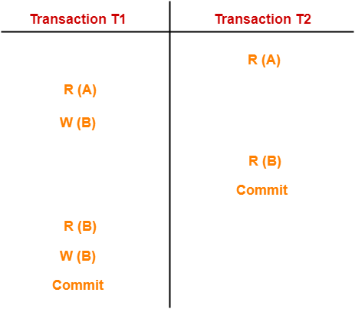

In this schedule,
- There are two transactions T1 and T2 executing concurrently.
- The operations of T1 and T2 are interleaved.
- So, this schedule is an example of a Non-Serial Schedule.

Finding Number Of Schedules-

Consider there are n number of transactions T1, T2, T3 …. , Tn with N1, N2, N3 …. , Nn number of operations respectively.

Total Number of Schedules-

Total number of possible schedules (serial + non-serial) is given by-

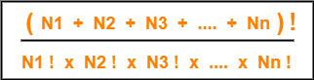

Total Number of Serial Schedules-

Total number of serial schedules
= Number of different ways of arranging n transactions
= n!

Total Number of Non-Serial Schedules-

Total number of non-serial schedules
= Total number of schedules – Total number of serial schedules

PRACTICE PROBLEM BASED ON FINDING NUMBER OF SCHEDULES-

Problem-

Consider there are three transactions with 2, 3, 4 operations respectively, find-
- How many total number of schedules are possible?
- How many total number of serial schedules are possible?
- How many total number of non-serial schedules are possible?

Solution-

Total Number of Schedules-

Using the above formula, we have-

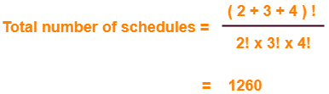

Total Number of Serial Schedules-

Total number of serial schedules
= Number of different ways of arranging 3 transactions
= 3!
= 6

Total Number of Non-Serial Schedules-

Total number of non-serial schedules
= Total number of schedules – Total number of serial schedules
= 1260 – 6
= 1254
We have discussed-
- A schedule is the order in which the operations of multiple transactions appear for execution.
- Serial schedules are always consistent.
- Non-serial schedules are not always consistent.

In DBMS, schedules may be classified as-

Serializability in DBMS-

- Some non-serial schedules may lead to inconsistency of the database.
- Serializability is a concept that helps to identify which non-serial schedules are correct and will maintain the consistency of the database.

Serializable Schedules-

If a given non-serial schedule of ‘n’ transactions is equivalent to some serial schedule of ‘n’ transactions, then it is called as a serializable schedule.

Characteristics-

Serializable schedules behave exactly same as serial schedules.
Thus, serializable schedules are always-
- Consistent
- Recoverable
- Casacadeless
- Strict

Serial Schedules Vs Serializable Schedules-

Serial Schedules | Serializable Schedules
No concurrency is allowed.  Thus, all the transactions necessarily execute serially one after the other. | Concurrency is allowed.  Thus, multiple transactions can execute concurrently.
Serial schedules lead to less resource utilization and CPU throughput. | Serializable schedules improve both resource utilization and CPU throughput.
Serial Schedules are less efficient as compared to serializable schedules.  (due to above reason) | Serializable Schedules are always better than serial schedules.  (due to above reason)

Types of Serializability-

Serializability is mainly of two types-

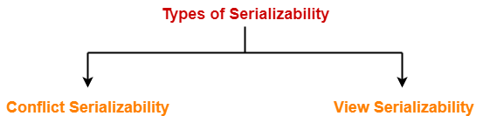

- Conflict Serializability
- View Serializability

Conflict Serializability-

If a given non-serial schedule can be converted into a serial schedule by swapping its non-conflicting operations, then it is called as a conflict serializable schedule.

Conflicting Operations-

Two operations are called as conflicting operations if all the following conditions hold true for them-
- Both the operations belong to different transactions
- Both the operations are on the same data item
- At least one of the two operations is a write operation

Example-

Consider the following schedule-

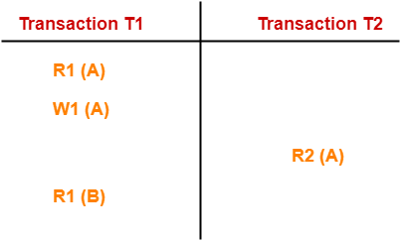

In this schedule,
- W1 (A) and R2 (A) are called as conflicting operations.
- This is because all the above conditions hold true for them.

Checking Whether a Schedule is Conflict Serializable Or Not-

Follow the following steps to check whether a given non-serial schedule is conflict serializable or not-

Step-01:

Find and list all the conflicting operations.

Step-02:

Start creating a precedence graph by drawing one node for each transaction.

Step-03:

- Draw an edge for each conflict pair such that if X_{i} (V) and Y_{j} (V) forms a conflict pair then draw an edge from T_{i} to T_{j}.
- This ensures that T_{i} gets executed before T_{j}.

Step-04:

- Check if there is any cycle formed in the graph.
- If there is no cycle found, then the schedule is conflict serializable otherwise not.

Concurrency Problems in DBMS-

- When multiple transactions execute concurrently in an uncontrolled or unrestricted manner, then it might lead to several problems.
- Such problems are called as concurrency problems.

The concurrency problems are-

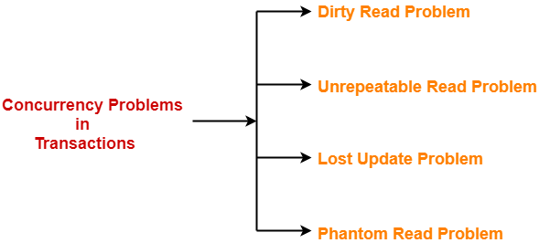

- Dirty Read Problem
- Unrepeatable Read Problem
- Lost Update Problem
- Phantom Read Problem

1. Dirty Read Problem-

Reading the data written by an uncommitted transaction is called as dirty read.

This read is called as dirty read because-
- There is always a chance that the uncommitted transaction might roll back later.
- Thus, uncommitted transaction might make other transactions read a value that does not even exist.
- This leads to inconsistency of the database.

NOTE-

- Dirty read does not lead to inconsistency always.
- It becomes problematic only when the uncommitted transaction fails and roll backs later due to some reason.

Example-

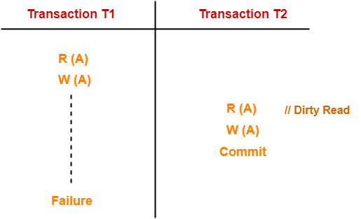

Here,
- T1 reads the value of A.
- T1 updates the value of A in the buffer.
- T2 reads the value of A from the buffer.
- T2 writes the updated the value of A.
- T2 commits.
- T1 fails in later stages and rolls back.

In this example,
- T2 reads the dirty value of A written by the uncommitted transaction T1.
- T1 fails in later stages and roll backs.
- Thus, the value that T2 read now stands to be incorrect.
- Therefore, database becomes inconsistent.

2. Unrepeatable Read Problem-

This problem occurs when a transaction gets to read unrepeated i.e. different values of the same variable in its different read operations even when it has not updated its value.

Example-

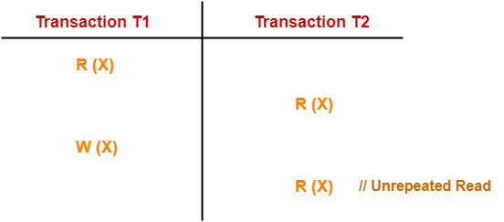

Here,
- T1 reads the value of X (= 10 say).
- T2 reads the value of X (= 10).
- T1 updates the value of X (from 10 to 15 say) in the buffer.
- T2 again reads the value of X (but = 15).

In this example,
- T2 gets to read a different value of X in its second reading.
- T2 wonders how the value of X got changed because according to it, it is running in isolation.

3. Lost Update Problem-

This problem occurs when multiple transactions execute concurrently and updates from one or more transactions get lost.

Example-

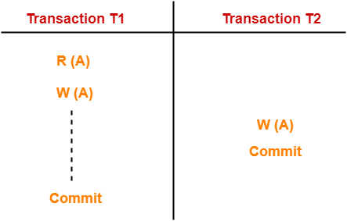

Here,
- T1 reads the value of A (= 10 say).
- T2 updates the value to A (= 15 say) in the buffer.
- T2 does blind write A = 25 (write without read) in the buffer.
- T2 commits.
- When T1 commits, it writes A = 25 in the database.

In this example,
- T1 writes the over written value of X in the database.
- Thus, update from T1 gets lost.

NOTE-

- This problem occurs whenever there is a write-write conflict.
- In write-write conflict, there are two writes one by each transaction on the same data item without any read in the middle.

4. Phantom Read Problem-

This problem occurs when a transaction reads some variable from the buffer and when it reads the same variable later, it finds that the variable does not exist.

Example-

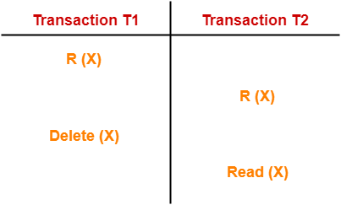

Here,
- T1 reads X.
- T2 reads X.
- T1 deletes X.
- T2 tries reading X but does not find it.

In this example,
- T2 finds that there does not exist any variable X when it tries reading X again.
- T2 wonders who deleted the variable X because according to it, it is running in isolation.

Avoiding Concurrency Problems-

- To ensure consistency of the database, it is very important to prevent the occurrence of above problems.
- Concurrency Control Protocols help to prevent the occurrence of above problems and maintain the consistency of the database.

Conflict Serializability-

We have discussed-
- The concept of serializability helps to identify the correct non-serial schedules that will maintain the consistency of the database.
- There are two types of serializability-

PRACTICE PROBLEMS BASED ON CONFLICT SERIALIZABILITY-

Problem-01:

Check whether the given schedule S is conflict serializable or not-
S : R₁(A) , R₂(A) , R₁(B) , R₂(B) , R₃(B) , W₁(A) , W₂(B)

Solution-

Step-01:

List all the conflicting operations and determine the dependency between the transactions-
- R₂(A) , W₁(A) (T₂ → T₁)
- R₁(B) , W₂(B) (T₁ → T₂)
- R₃(B) , W₂(B) (T₃ → T₂)

Step-02:

Draw the precedence graph-

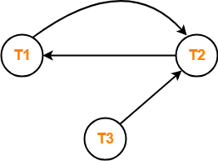

- Clearly, there exists a cycle in the precedence graph.
- Therefore, the given schedule S is not conflict serializable.

Problem-02:

Check whether the given schedule S is conflict serializable and recoverable or not-

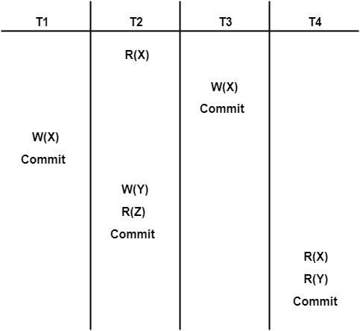

Solution-

Checking Whether S is Conflict Serializable Or Not-

Step-01:

List all the conflicting operations and determine the dependency between the transactions-
- R₂(X) , W₃(X) (T₂ → T₃)
- R₂(X) , W₁(X) (T₂ → T₁)
- W₃(X) , W₁(X) (T₃ → T₁)
- W₃(X) , R₄(X) (T₃ → T₄)
- W₁(X) , R₄(X) (T₁ → T₄)
- W₂(Y) , R₄(Y) (T₂ → T₄)

Step-02:

Draw the precedence graph-

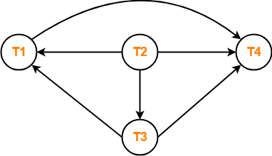

- Clearly, there exists no cycle in the precedence graph.
- Therefore, the given schedule S is conflict serializable.

Checking Whether S is Recoverable Or Not-

- Conflict serializable schedules are always recoverable.
- Therefore, the given schedule S is recoverable.

Alternatively,
- There exists no dirty read operation.
- This is because all the transactions which update the values commits immediately.
- Therefore, the given schedule S is recoverable.
- Also, S is a Cascadeless Schedule.

Problem-03:

Check whether the given schedule S is conflict serializable or not. If yes, then determine all the possible serialized schedules-

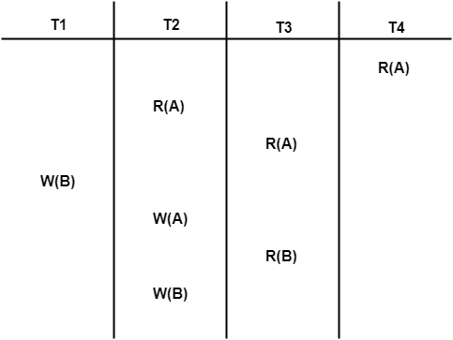

Solution-

Checking Whether S is Conflict Serializable Or Not-

Step-01:

List all the conflicting operations and determine the dependency between the transactions-
- R₄(A) , W₂(A) (T₄ → T₂)
- R₃(A) , W₂(A) (T₃ → T₂)
- W₁(B) , R₃(B) (T₁ → T₃)
- W₁(B) , W₂(B) (T₁ → T₂)
- R₃(B) , W₂(B) (T₃ → T₂)

Step-02:

Draw the precedence graph-

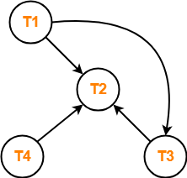

- Clearly, there exists no cycle in the precedence graph.
- Therefore, the given schedule S is conflict serializable.

Finding the Serialized Schedules-

- All the possible topological orderings of the above precedence graph will be the possible serialized schedules.
- The topological orderings can be found by performing the Topological Sort of the above precedence graph.

After performing the topological sort, the possible serialized schedules are-
- T₁ → T₃ → T₄ → T₂
- T₁ → T₄ → T₃ → T₂
- T₄ → T₁ → T₃ → T₂

Problem-04:

Determine all the possible serialized schedules for the given schedule-

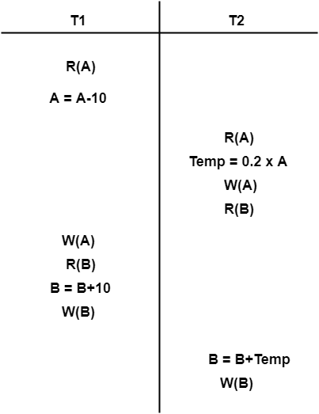

Solution-

The given schedule S can be rewritten as-
The given schedule S can be rewritten as-

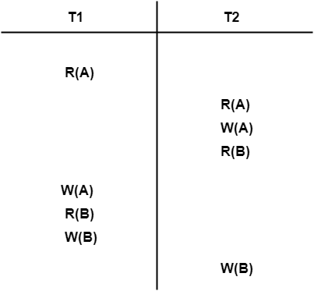

This is because we are only concerned about the read and write operations taking place on the database.

Checking Whether S is Conflict Serializable Or Not-

Step-01:

List all the conflicting operations and determine the dependency between the transactions-
- R₁(A) , W₂(A) (T₁ → T₂)
- R₂(A) , W₁(A) (T₂ → T₁)
- W₂(A) , W₁(A) (T₂ → T₁)
- R₂(B) , W₁(B) (T₂ → T₁)
- R₁(B) , W₂(B) (T₁ → T₂)
- W₁(B) , W₂(B) (T₁ → T₂)

Step-02:

Draw the precedence graph-

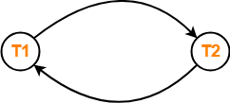

- Clearly, there exists a cycle in the precedence graph.
- Therefore, the given schedule S is not conflict serializable.
- Thus, Number of possible serialized schedules = 0.

View Serializability in DBMS

We have discussed-
- The concept of serializability helps to identify the correct non-serial schedules that maintains the consistency of the database.
- There are two types of serializability-

View Serializability-

If a given schedule is found to be view equivalent to some serial schedule, then it is called as a view serializable schedule.

Also read-Schedules in DBMS

View Equivalent Schedules-

Consider two schedules S1 and S2 each consisting of two transactions T1 and T2.
Schedules S1 and S2 are called view equivalent if the following three conditions hold true for them-

Condition-01:

For each data item X, if transaction T_{i} reads X from the database initially in schedule S1, then in schedule S2 also, T_{i} must perform the initial read of X from the database.

Thumb Rule
“Initial readers must be same for all the data items”.

Condition-02:

If transaction T_{i} reads a data item that has been updated by the transaction T_{j} in schedule S1, then in schedule S2 also, transaction T_{i} must read the same data item that has been updated by the transaction T_{j.}

Thumb Rule
“Write-read sequence must be same.”.

Condition-03:

For each data item X, if X has been updated at last by transaction T_{i} in schedule S1, then in schedule S2 also, X must be updated at last by transaction T_{i}.

Checking Whether a Schedule is View Serializable Or Not-

Method-01:

Check whether the given schedule is conflict serializable or not.
- If the given schedule is conflict serializable, then it is surely view serializable. Stop and report your answer.
- If the given schedule is not conflict serializable, then it may or may not be view serializable. Go and check using other methods.

Thumb Rules
- All conflict serializable schedules are view serializable.
- All view serializable schedules may or may not be conflict serializable.

Method-02:

Check if there exists any blind write operation.
(Writing without reading is called as a blind write).
- If there does not exist any blind write, then the schedule is surely not view serializable. Stop and report your answer.
- If there exists any blind write, then the schedule may or may not be view serializable. Go and check using other methods.

Thumb Rule
No blind write means not a view serializable schedule.

Method-03:

In this method, try finding a view equivalent serial schedule.
- By using the above three conditions, write all the dependencies.
- Then, draw a graph using those dependencies.
- If there exists no cycle in the graph, then the schedule is view serializable otherwise not.

